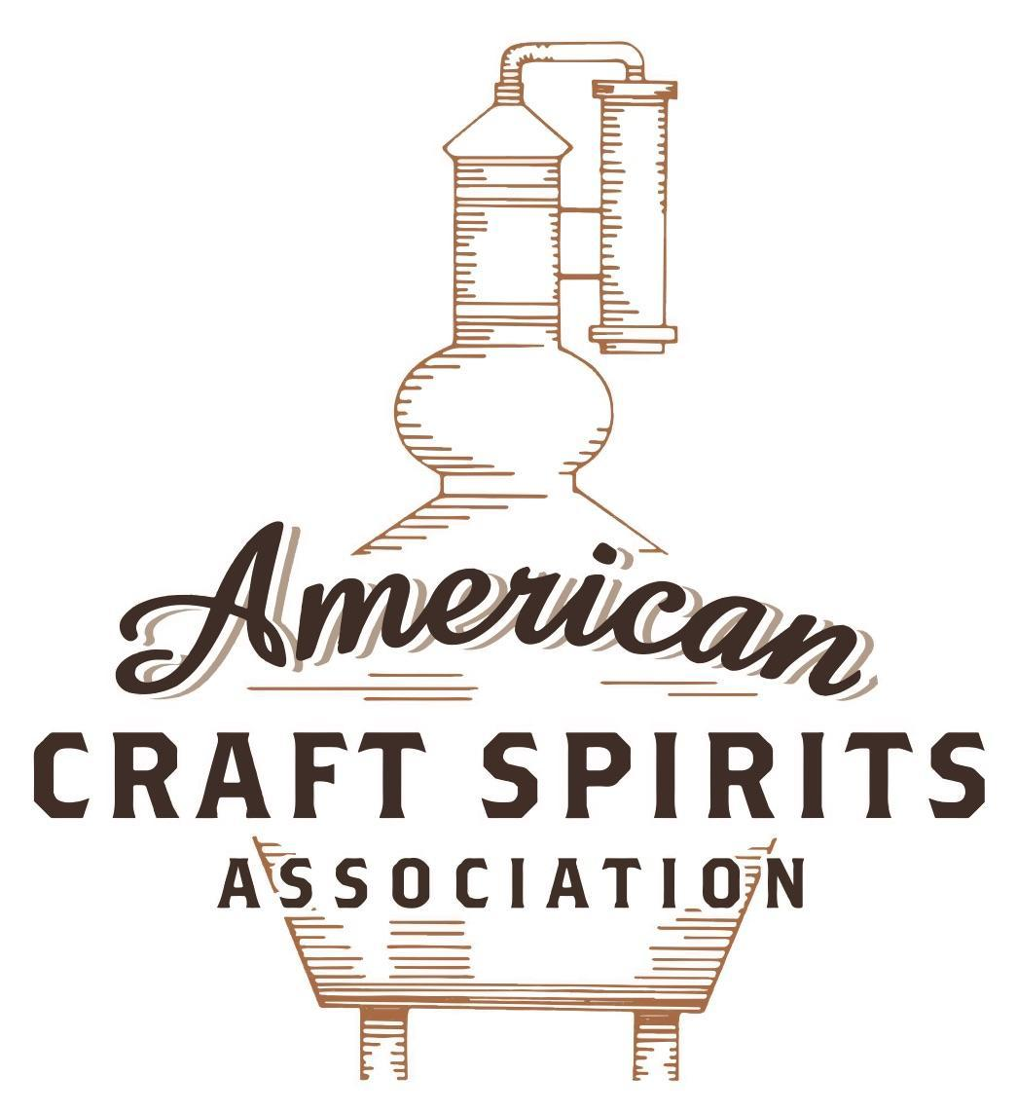
Spirits DtC Shipping Guide

This guide summarizes the direct-to-consumer shipping rules for distilleries in all 50 states and D.C. and also addresses the measures state governments have taken to ease delivery and shipping restrictions during the COVID-19 pandemic.

DtC Quick Guide Comparison

Out-of-State Distilleries  Can Ship Into State? |  |  |  | In-State Distilleries  Can Ship Within State?
State | Yes | No |  | State | Yes | No
AL |  | X |  | AL |  | X
AK | X |  |  | AK | X
AZ | X |  |  | AZ | X
AR |  | X |  | AR |  | X
CA |  | X* |  | CA |  | X*
CO |  | X |  | CO |  | X
CT |  | X* |  | CT |  | X
DE |  | X |  | DE |  | X
DC | X |  |  | DC | X
FL |  | X |  | FL |  | X
GA |  | X |  | GA |  | X
HI |  | X* |  | HI |  | ?*
ID |  | X |  | ID |  | X
IL |  | X* |  | IL |  | X*
IN |  | X |  | IN |  | X
IA |  | X* |  | IA |  | X*
KS |  | X |  | KS |  | X
KY | X |  |  | KY | X
LA |  | X |  | LA |  | X
ME |  | X* |  | ME |  | X*
MD |  | X |  | MD |  | X
MA |  | X |  | MA |  | X
MI |  | X |  | MI |  | X
MN |  | X |  | MN |  | X
MS |  | X |  | MS |  | X
MO |  | X |  | MO |  | X
MT |  | X |  | MT |  | X
NE | X |  |  | NE | X
NV |  | X* |  | NV |  | X
NH | X |  |  | NH |  | X*
NJ |  | X* |  | NJ |  | X*
NM |  | X |  | NM |  | X
NY |  | X* |  | NY |  | X*
NC |  | X |  | NC |  | X
ND | X |  |  | ND | X
OH |  | X |  | OH |  | X
OK |  | X |  | OK |  | X
OR |  | X |  | OR | X
PA |  | X* |  | PA |  | X
RI |  | X* |  | RI |  | X
SC |  | X |  | SC |  | X
SD |  | X |  | SD |  | X
TN |  | X |  | TN |  | X
TX |  | X |  | TX |  | X
UT |  | X |  | UT |  | X
VT |  | X |  | VT |  | X
VA |  | X |  | VA |  | X
WA |  | X* |  | WA | X
WV |  | X* |  | WV |  | X*

WI |  | X |  | WI |  | X
WY |  | X |  | WY |  | X

Notes:
*CA: If passed and signed into law, Senate Bill 620 would allow licensed distilled spirits producers in states other than California and licensed distilled spirits manufacturers or craft distillers in California who obtain distilled spirits direct shipper permits to ship directly to consumers in California
*CT: Consumers with appropriate permit may receive alcohol shipments
*HI: Consumers with appropriate permit may receive alcohol shipments; If passed and signed into law, Senate Bill 65 would allow licensed distilled spirits manufacturers in Hawaii and in states other than Hawaii who obtain direct shipper permits to ship directly to consumers in Hawaii
*IL: If passed and signed into law, Senate Bill 0532 would allow licensed distilled spirits producers in Illinois and in states other than Illinois who obtain distillery shippers’ licenses to ship directly to consumers in Illinois
*IA: If passed and signed into law, House File 639 would allow native distilled spirits manufacturers in Iowa and in states other than Iowa who obtain direct shipper permits to ship directly to consumers in Iowa and to consumers in states other than Iowa
*ME: If passed and signed into law, Legislative Document 1358 would allow distilleries outside of Maine with current manufacturer licenses and distilleries licensed in Maine who obtain spirits direct shipper licenses to ship directly to consumers in Maine
*NJ: (1) If passed and signed into law, Assembly Bill 3167 would allow a craft distillery licensees to ship no more than 9 liters of distilled spirits to a consumer in New Jersey; (2) If passed and signed into law, Senate Bill 3020 would allow craft distillery licensees in New Jersey or in states other than New Jersey to ship no more than 20 liters of distilled spirits to a consumer in New Jersey via common carrier
*NV: Licensed individuals can import one gallon per month of spirits for personal use and the out-of-state supplier must pay excise tax
*NH: If passed and signed into law, Senate Bill 125 would allow licensed liquor manufacturers who obtain direct to consumer shipping permits from the commission to ship directly to consumers in New Hampshire
*NY: Consumer may import up to 90L of liquor per year for personal use without a license; If passed and signed into law, Assembly Bill 3275 would allow licensed liquor manufacturers in states other than New York and licensed distillers and farm distillers in New York to ship no more than thirty-six cases (no more than nine liters per case) of liquor to consumers in New York
*PA: Consumer may place a special liquor order and distiller must ship to a PLCB-operated store
*RI: Distiller can only ship to customer if order was personally placed by customer at distiller's premises
*WA: If passed and signed into law, House Bill 1432 would allow licensed spirits manufacturers in states other than Washington to ship spirits to consumers in Washington
*WV: Distilleries, mini-distilleries, or micro-distilleries licensed in West Virginia or a state other than West Virginia who obtain private direct shipper licenses to ship to a consumer in West Virginia, however the shipments must be made to a retail liquor outlet

NEBRASKA

Shipment Outbound – Yes, if permitted by the purchaser’s applicable law (NE R.S. § 53-123.01).

Shipment Inbound – Yes, with a shipping license (NE R.S. § 53-123.15(4)).

Shipment Intra-state – Yes, with a shipping license (NE R.S. § 53-123.15(2)).

COVID-19 Measures – Nebraska waived the requirement which mandates that alcohol be sold in original packages to allow pre-made cocktails to be sold as long as the containers are sealed with a lid or other method of securing the product. L.B. 274, signed and enacted into law on May 26, 2021, allows the holder of a Class C liquor license and the holder of a Class I liquor license to sell alcoholic liquor as a mixed drink or cocktail, instead of selling liquor in its original package, to a consumer who is at least 21 years of age for consumption off the licensed premises if the liquor is not partially consumed and in a labeled and sealed container with a tamper-evident lid, cap, or seal.
Industry Advisory - Retail Operations Link: https://lcc.nebraska.gov/sites/lcc.nebraska.gov/files/Industry%20Advisory%20-%20Retail%20Operations.pdf
L.B. 274 Link: https://nebraskalegislature.gov/FloorDocs/107/PDF/Slip/LB274.pdf
Citation (shipment)
Nebraska Revised Statutes
§ 53-123.01. Manufacturer's license; rights of licensee; craft brewery license holder; when required to obtain manufacturer’s license; rights of holder.
(1) A manufacturer's license shall allow the manufacture, storage, and sale of alcoholic liquor to wholesale licensees in this state and to such persons outside the state as may be permitted by law, except that nothing in the Nebraska Liquor Control Act shall prohibit a manufacturer of beer from distributing tax-paid samples of beer at the premises of a licensed manufacturer for consumption on the premises. A manufacturer's license issued pursuant to this section shall be the only license required by the Nebraska Liquor Control Act for the manufacture and retail sale of beer manufactured on the licensed premises for consumption on the licensed premises.
Link: https://nebraskalegislature.gov/laws/statutes.php?statute=53-123.01
§ 53-123.15. Shipping license; when required; rights of licensee; application; contents; violation; disciplinary action; holder of license; duties; report; contents.
(1) No person shall order or receive alcoholic liquor in this state which has been shipped directly to him or her from outside this state by any person other than a holder of a shipping license issued by the commission, except that a licensed wholesaler may receive not more than three gallons of wine in any calendar year from any person who is not a holder of a shipping license.
(2) The commission may issue a shipping license to a manufacturer. Such license shall allow the licensee to ship alcoholic liquor only to a licensed wholesaler. A person who receives a license pursuant to this subsection shall pay the fee required in sections 53-124 and 53-124.01 for a manufacturer's shipping license. Such fee shall be collected by the commission and be remitted to the State Treasurer for credit to the General Fund, except that the fee received for a shipping license issued to a beer manufacturer pursuant to this subsection shall be credited to the Nebraska Beer Industry Promotional Fund.
(4) The commission may issue a shipping license to any manufacturer who sells and ships alcoholic liquor from another state directly to a consumer in this state if the manufacturer satisfies the requirements of subsections (7) through (9) of this section. A manufacturer who receives a license pursuant to this subsection shall pay the fee required in sections 53-124 and 53-124.01 for a manufacture direct sales shipping license. Such fee shall be collected by the commission and remitted to the State Treasurer for credit to the Winery and Grape Producers Promotional Fund.
(7) The application for a shipping license under subsection (4) or (5) of this section shall be in such form as the commission prescribes. The application shall require an applicant which is a manufacturer, a craft brewery, a craft distillery, or a farm winery to identify the brands of alcoholic liquor that the applicant is requesting the authority to ship either into or within Nebraska. For all applicants, unless otherwise provided in this section, the application shall contain all provisions the commission deems proper and necessary to effectuate the purpose of any section of the act and the rules and regulations of the commission that apply to manufacturers or retailers and shall include, but not be limited to, provisions that the applicant, in consideration of the issuance of such shipping license, agrees:
(a) To comply with and be bound by sections 53-162 and 53-164.01 in making and filing reports, paying taxes, penalties, and interest, and keeping records;
(b) To permit and be subject to all of the powers granted by section 53-164.01 to the commission or its duly authorized employees or agents for inspection and examination of the applicant's premises and records and to pay the actual expenses, excluding salary, reasonably attributable to such inspections and examinations made by duly authorized employees of the commission if within the United States;
(c) That if the applicant violates any of the provisions of the application or the license, any section of the act, or any of the rules and regulations of the commission that apply to manufacturers or retailers, the commission may suspend, cancel, or revoke such shipping license for such period of time as it may determine;
(d) That the applicant agrees to notify the commission of any violations in the state in which he or she is domiciled and any violations of the direct shipping laws of any other states. Failure to notify the commission within thirty days after such a violation may result in a hearing before the commission pursuant to which the license may be suspended, canceled, or revoked; and
(e) That the applicant, if a manufacturer, craft brewery, craft distillery, or farm winery, agrees to notify any wholesaler licensed in Nebraska that has been authorized to distribute such brands that the application has been filed for a shipping license. The notice shall be in writing and in a form prescribed by the commission. The commission may adopt and promulgate rules and regulations as it reasonably deems necessary to implement this subdivision, including rules and regulations that permit the holder of a shipping license under this subdivision to amend the shipping license by, among other things, adding or deleting any brands of alcoholic liquor identified in the shipping license.
(8) Any manufacturer or retailer who is granted a shipping license under subsection (4) or (5) of this section shall:
(a) Only ship the brands of alcoholic liquor identified on the application;
(b) Only ship alcoholic liquor that is owned by the holder of the shipping license;
(c) Only ship alcoholic liquor that is properly registered with the Alcohol and Tobacco Tax and Trade Bureau of the United States Department of the Treasury;
(d) Not ship any alcoholic liquor products that the manufacturers or wholesalers licensed in Nebraska have voluntarily agreed not to bring into Nebraska at the request of the commission;
(e) Not ship more than nine liters of alcoholic liquor per month to any person in Nebraska to whom alcoholic beverages may be lawfully sold. All such sales and shipments shall be for personal consumption only and not for resale; and
(f) Cause the direct shipment of alcoholic liquor to be by approved common carrier only. The commission shall adopt and promulgate rules and regulations pursuant to which common carriers may apply for approval to provide common carriage of alcoholic liquor shipped by a holder of a shipping license issued pursuant to subsection (4) or (5) of this section. The rules and regulations shall include provisions that require (i) the recipient to demonstrate, upon delivery, that he or she is at least twenty-one years of age, (ii) the recipient to sign an electronic or paper form or other acknowledgment of receipt as approved by the commission, and (iii) the commission-approved common carrier to submit to the commission such information as the commission may prescribe. The commission-approved common carrier shall refuse delivery when the proposed recipient appears to be under the age of twenty-one years and refuses to present valid identification. All holders of shipping licenses shipping alcoholic liquor pursuant to this subdivision shall affix a conspicuous notice in sixteen-point type or larger to the outside of each package of alcoholic liquor shipped within or into the State of Nebraska, in a conspicuous location, stating: CONTAINS ALCOHOLIC BEVERAGES; SIGNATURE OF PERSON AT LEAST 21 YEARS OF AGE REQUIRED FOR DELIVERY. Any delivery of alcoholic beverages to a minor by a common carrier shall constitute a violation by the common carrier. The common carrier and the holder of the shipping license shall be liable only for their independent acts.
(9) For purposes of sections 53-160, 77-2703, and 77-27,142, each shipment of alcoholic liquor by the holder of a shipping license under subsection (3), (4), or (5) of this section shall constitute a sale in Nebraska by establishing a nexus in the state. The holder of the shipping license shall collect all the taxes due to the State of Nebraska and any political subdivision and remit any excise taxes monthly to the commission and any sales taxes to the Department of Revenue.
Link: https://nebraskalegislature.gov/laws/statutes.php?statute=53-123.15

The American Craft Spirits Association (ACSA) is working diligently to give our members and industry partners relevant, current updates on statutes and regulations impacting production, sale and distribution of spirits. With the declaration of the novel coronavirus (COVID-19) in early 2020, many states have issued temporary policy changes or longer-term modernization of alcohol beverage laws. State statutes, regulations created by the state alcohol regulatory authority, as well as any other relevant guidance provided by such authorities (such as advisories, opinions, bulletins, etc.) were reviewed in creation of this document. No city or county ordinances were reviewed. Distillers should be aware that even in states where direct shipping is permissible, always remember to avoid shipping to dry counties. Please consult with your state guild or alcohol beverage authority for the most up-to-date information. This content is intended for educational and informational purposes only. ACSA's pro bono law firm of Malkin Law P.A. provided the core content found in this comprehensive overview of the spirits distribution after COVID-19. It was completed in August 2021 and will be updated regularly. If you have updates you would like to provide, please send to legislation@americancraftspirits.org or directly to the law firm at: ryan@malkin.law / malkin.law. Thank you.

